Task:-

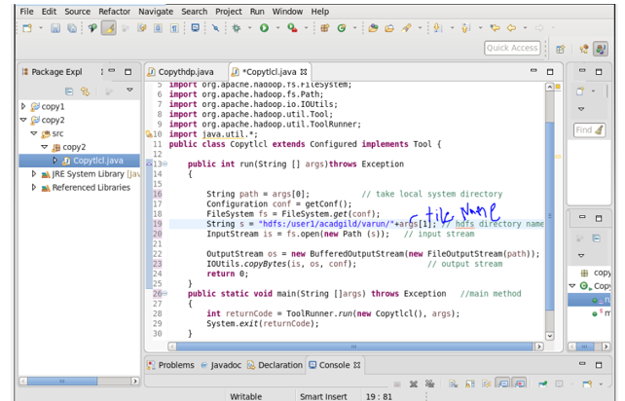

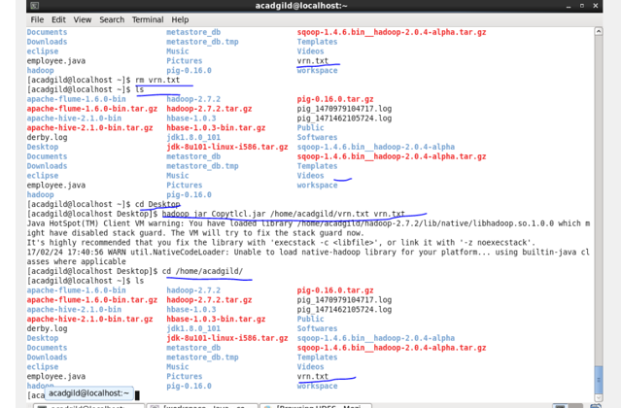

Task 2:-

DFS Input Stream :

1) Communication of name node with various data nodes is handled by this

2) Integrity of data by the blocks is handled by this.

3) It Manages data read activity in case of data node failure.

4) It is Called internally by FS Data Input Stream.

FS Data Input Stream :

It Provides stream (channel) for reading data. FS Data Input Stream Lets the application read from a file

FS Data Input Stream in = null;

in = fs.open(new Path(uri));

FS Data Output Stream :

It Provides stream (channel) for writing data.

Output Stream out = fs.create(new Path(dst));

IOUtils.copyBytes(in, out, 4096, true);

DFS Output Stream :

1) Communication of name nodes with various data nodes is handled .

2) FS Data Output Stream calls it internally.